CHAPTER 1
Introduction and Its Background
Introduction
Playing games is one way to enjoy ourselves and sometimes gives positive feelings for motivation. There are many types of games. Games that you can play outdoors. Technology brought us console games like family computer, SNES, Gameboy, Play station and many more that needs to be plugged in order to play. As technology grows further, inventors did not stop creating new things for us to play at ease. They created Gameboy, Play station portable which is powered by battery.
Technology continue to evolve, from beeper/pager where we can receive Short Message Service or what we all know as SMS. As years passed by, until cellphones are invented where in you can receive SMS and at the same time can call from cellphone to cellphone. On the latter part, mobile devices that enables us to watch movies, call, send messages, connect to the internet, download applications and play games.
The proponent will develop NinJump using kinetic movement algorithm with photoshop 5 for graphics design and Unity engine for simulation development. It will also use Mobile phones as a commonly used nowadays.
Background of the Study
Trampoline Time is one of Mario's minigames in Super Mario 64 DS and a Variety Minigame in New Super Mario Bros.. In this minigame, the player has to draw trampolines so that the Mario clones can jump on them and bounce to open windows.
The game starts with a giant trampoline that will disappear after three Marios land on it. A player can draw more trampolines with the Stylus; however, they will disappear with only one Mario landing on them. If a Mario lands on the center of a trampoline, he will bounce higher than normal. Also, if a Mario hits a wall at the right angle, he will jump off of it for even more vertical distance. If three Mario clones fall off the screen, the game ends.
It bears some resemblance to Big Ape City from Donkey Kong Land. Also, the music for this mini-game is the same as the Super Mario Sunshine secret level music.
In the development of the proposed study, the proponent will implement the algorithm called, “Kinetic Algorithm”.
The proponent choose this study to apply his skills and knowledge in software analysis and design in creating software, thus giving the proponent more confident in his own field.
This has to decide to develop NinJump is to promote the Indie Game Developers called the Retrobyte and to hone his skills in programming especially in game development.

Theoretical/Conceptual Framework of the Study
Input
Process
Output
Knowledge Requirements
-Programming skills in game development particular in 2d.
-Kinematic Movement Algorithms Arriving Behavior.
-Path following Algorithm
2D Game Development
-System Concept
-Planning
-Analysis and Design
-Development
-Integration
-Deployment
Mobile version of Trampoline Time called NinJump
Applying Kinematic Movement Algorithm.

Figure 1 Conceptual Framework of the Existing System
To create successful game, knowledge and skills are needed. Since NinJump is focused on implementing a Nintendo DS game on mobile device, familiarity in the game and mobile game development is needed. The development of the project requires idea about Trampoline Time, Game Development (2D), Kinematic Movement Algorithm: Arriving Behavior and Path Following Algorithm.
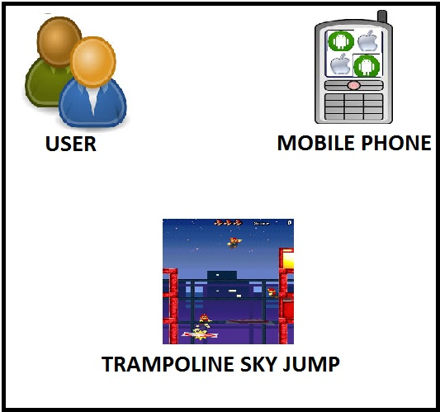
Figure 2 Theoretical Framework of the Proposed Trampoline Sky Jump
The framework is built from a set of concepts linked to a planned or existing manual system of methods, behaviors, functions, relationships and object.
Statement of the Problem:
The focus of the study is to develop mobile rendition of Trampoline Time.
Specifically, it will seek to solve the following problems:
- How does the respondent describe the Trampoline Time in Nintendo DS Version in terms of the following:
1.1 Portability
  - Reliability
  - Usability
- What are the problems encountered in the existing process?
- What are design considerations for the development of NinJump in terms of the following:
3.1 Kinematic Movement Algorithm (Arriving Behavior)
3.2 Kinematic Movement Algorithm (Steering Algorithm Obstacle Avoidance)
3.3 Path Following Algorithm
3.2 Hardware and Software Requirements
4. How does the proposed software be evaluated in terms of the following:
4.1 Portability
4.2. Reliability
4.3 Usability
Hypothesis of the Study
There is no significant difference between the Trampoline Jump and NinJump.
Scope and Limitations
The proposed system is compatible with mobile phones with Android OS/iOS only and Algorithm that the proponent to be implemented is limited only using Kinetic Algorithm. The game will be played by one player only. It can be played with or without internet connection, however once the game is uploaded in the Google Playstore, the game will be downloaded using internet connection.
Significance of the Study
Trampoline Sky Jump is cited by the proponent to be significant to the following:
RetroByte.Ninja. The Indie Game Developers which will be having a great part in developing the system.
Proponent. It gives the proponent the chance to apply the skills and knowledge the proponent has acquired in the past years of studying.
Future Researchers. This study will serve as a guide and reference to any future researchers who desires to develop a study of the same topic.

Definition of Terms
The proponent defined the following operational and conceptual terms for better understanding.
Algorithm. A process or set of rules to be followed in calculations or other problem-solving operations, especially by a computer.
Android OS/iOS. An operating system used by smartphones nowadays.
Ease of Use. Is the ease of use and learnability of a human-made object.
Kinetic Movement. Defined as the work needed to accelerate a body of a given mass from the rest of its stated velocity.
Nintendo Dual Screen. Is a dual screen handheld game console developed and released by Nintendo.
Portability. Characterizes the ability to the system to change the new specifications or operating environments. Characterizes the effort required to install the software. Characterizes the plug and play aspect of the software components, that is how easy is it to exchange a given software component within a specified environment.
Retrobyte. From the word retro which means old and byte from computer terms. Retrobyte a team name of an Indie Game Developer that will help finish this study.

